**Stanley College of Engineering and Technology for Women(Autonomous)**

**Chapel road, Abids, Hyderabad-500001**

**(Affiliated to Osmania University, Hyderabad, Approved by AICTE, Accredited by**

**NBA & NAAC with A Grade)**



**2024 Department of Computer Science and Engineering**

**STUDENT DETAILS :**

| **Batch No** | **Roll No** | **Name** | **Title** |
| --- | --- | --- | --- |
| CSE-C 008 | 160621733133 | Avula Mahathi | WildLife Explorer: Journey into the Heart of the Wild with AI-Powered Voice Assistant |
| 160621733144 | Gajjela Jahnavi |
| 160621733193 | Jakkidi Hudamaie Reddy |

**GUIDE DETAILS :**

**Internal Guide :** Ms.M.Tejaswee Reddy, Asst. Professor, CSE at Stanley College of Engineering and Technology For Women.

**External Guide :**

**Coordinator :** Dr. Shivani Yadao  **HOD:** Dr.YVSS Pragathi

**ACKNOWLEDGEMENT**

I wish to express my sincere thanks to Sri. Kodali Krishna Rao, Correspondent and Secretary,for providing me with all the necessary facilities.

I place on record, my sincere gratitude to Dr. Satya Prasad Lanka, Principal, for his constantEncouragement.

I deeply express my sincere thanks to our Head of the Department, Dr. Y.V.S Sai Pragathi, forencouraging and allowing me to present the project work on the topic “ **WildLife Explorer: Journey into the Heart of the Wild with AI-Powered Voice Assistant** “at our department premises for the partial fulfilment of the requirements leading to the award of the B.E. degree.

It is my privilege to express sincere regards to my Project Guide Ms. M. Tejaswee Reddy for thevaluable inputs, able guidance, encouragement, whole-hearted cooperation and constructivecriticism throughout the duration of the project.

I thank my Project Coordinator Mrs. Dr. Shivani Yadao for her guidance and support throughoutthe duration of the project. I take this opportunity to thank all the faculty, who have directly orindirectly helped the project.

Last but not the least, I express my thanks to my friends for their cooperation and support.

**WILDLIFE EXPLORER :**

**JOURNEY INTO THE HEART OF THE WILD WITH AI- POWERED VOICE ASSISTANT.**

**INDEX**

| **S No.** | **Table Of Contents** | **Page No.** |
| --- | --- | --- |
| 1. | Abstract | 5 |
| 2. | Literature Survey | 6-8 |
| 3. | Modelling | 9-11 |
| 4. | Architecture | 12-13 |
| 5. | Hardware and Software Review | 14-18 |
| 6. | Outputs | 19-21 |
| 7. | Conclusion | 22 |

**ABSTRACT**

The Wild Life Explorer is a cutting-edge web application that offers users an immersive virtual zoo experience, enhanced by AI-driven voice assistance. Unlike traditional virtual zoo platforms that rely heavily on 3D graphics, this project focuses on delivering real-time animal behavior insights and educational content through dynamic voice interactions. Users can explore a 360-degree view of the zoo, where all animals are visible .Selecting individual animals to receive comprehensive, real-time insights into their behaviors and lifestyles narrated by an AI assistant. The web application is designed to be both entertaining and educational, appealing to users of all ages. The AI voice assistant utilizes advanced Natural Language Processing (NLP) and Text-to-Speech (TTS) technologies to provide context-aware responses, making the experience interactive and personalized. The application ensures a seamless and engaging experience without the need for resource-intensive 3D modeling, setting it apart from existing virtual zoo platforms. In addition to the visual and auditory experience, the platform incorporates a knowledge repository, allowing users to ask questions and receive informative responses about the animals, their ecosystems, and conservation efforts. The goal is to create an accessible, informative, and entertaining platform that provides users with a deeper understanding of wildlife, making it a unique and innovative tool for education and awareness.

**Key Words**: Wild life explorer, Virtual zoo, AI-driven, Voice assistance, Real-time insights, Natural language processing (NLP), Text-to-speech (TTS), Educational content

**LITERATURE SURVEY**

| **Author** | **Year** | **Methodology** | **Key Work/Findings** | **Gaps/Limitations in Existing Work** | **How Our Project Addresses the Gap** |
| --- | --- | --- | --- | --- | --- |
| **Wu et al.** | 2023 | Generative AI agents for virtual interactions | Focused on creating highly interactive virtual agents using generative AI, enabling immersive environments. | Heavy reliance on 3D simulations that require high computational power, limiting accessibility for general users. | By eliminating 3D modeling, our project uses lightweight AI-driven voice assistance for real-time animal behavior descriptions, reducing resource usage and ensuring broader accessibility. |
| **Zhang et al.** | 2022 | Natural Language Processing (NLP) with large models | Leveraged large language models (e.g., OPT) for generating human-like responses in conversational systems. | Complex models increase latency, require large datasets, and are computationally expensive. | We utilize lightweight NLP tools optimized for real-time performance, ensuring fast, responsive, and personalized voice interactions with minimal latency. |
| **Ramamurthy et al.** | 2022 | Reinforcement Learning (RL) for conversational AI | Applied RL to develop systems capable of engaging in meaningful, adaptive conversations based on user inputs. | RL-based systems demand extensive training datasets and computational power, which increase development costs. | By employing pre-trained NLP and TTS (Text-to-Speech) models, our project reduces computational overhead while delivering a high-quality conversational AI experience. |
| **Solotorio & Dupriez** | 2023 | AI models for relational data synhesis | Developed AI systems for synthesizing and analyzing relational data, enabling improved decision-making processes. | These systems focus primarily on data relationships and lack user interaction or engagement features. | Combines interactive voice AI with education-focused and engaging content, enhancing user interaction while providing informative experiences in the virtual zoo. |
| **Peng et al.** | 2023 | PyGlove for collaborative machine learning research | Focused on enabling flexibility and collaboration in machine learning research, with some real-world applications in data sharing and experimentation. | Applications are largely research-based, with limited usability in practical, user-facing systems. | Integrates ML into a user-facing platform by providing voice-guided educational features, relevant and beneficial to the end user for wildlife exploration and learning. |

**MODELLING**

### **1. User Interaction Model :**

This component outlines how users interact with the system through a graphical user interface (GUI) and mini-games.

* **Main Features:**

Home Page:

Acts as the central hub, displaying navigation buttons to access different sections.

Sections:

* + - **About Us:** Information about the virtual zoo's mission, vision, and development team.
    - **Animal Descriptions:** A categorized library of animal profiles, featuring details such as habitats, behaviors, and conservation status.
    - **Stories:** Engaging narratives or trivia about animals to create an emotional connection with users.
    - **Tour Guide:** Simulates a guided tour, presenting curated information about various exhibits in a sequence.
    - **Search:** Allows users to search for animals or specific topics.

### **2. Voice Assistant Model :**

The voice assistant is designed to answer user questions based on an integrated zoo encyclopedia.

* **Inputs:**
  + Users can type or use voice commands to ask questions about animals, habitats, or conservation topics.
* **Process:**
  + Queries are processed through a natural language understanding (NLU) module.
  + The system matches user questions with the encyclopedia database to generate relevant answers.
* **Outputs:**
  + Responses are displayed as text and optionally read aloud using text-to-speech (TTS) technology.

### **3. Mini-Game Models :**

Two interactive mini-games are included to enhance engagement and learning:

#### **a. Animal Card Matching Game**

* Objective: Match pairs of animal cards within a set time limit.
* Game Mechanics:
  + Cards are shuffled and displayed face-down.
  + Users flip two cards at a time to find matches.
  + Correct matches remain face-up, while incorrect ones flip back after a short delay.
* Timer: A countdown timer adds urgency, increasing the game’s difficulty.
* Scoring: Points are awarded for each correct match; bonuses may apply for faster completion.

#### **b. Blurred Image Guessing Game :**

* Objective: Identify animals from blurred images before the timer runs out.
* Game Mechanics:
  + An image of an animal is shown in a blurred state.
  + Users type or select the animal's name from multiple choices.
  + The image gradually becomes clearer as time progresses.
* Timer: Adds challenge by limiting the time to guess.
* Feedback: Immediate feedback on correctness, with an option to display the correct answer if the user is wrong.

### **4. Data Flow Model :**

This model describes how data flows between components.

* **Input Sources:**
  + User inputs (button clicks, voice commands, text entries).
  + Preloaded animal encyclopedia and multimedia content.
* **Processing:**
  + User interactions are processed to fetch relevant data from the database.
  + Mini-game logic calculates results and manages timers.
* **Output:**
  + Information is displayed on the GUI or narrated by the voice assistant.
  + Mini-game results are shown as scores and completion times.

### **5. System Logic Model :**

* **Navigation:**
  + Each button on the home page links to specific features or sections.
  + Navigation is intuitive, ensuring users can explore the zoo effortlessly.
* **Dynamic Content Loading:**
  + Content is loaded on-demand to minimize load times and resource usage.
* **Real-Time Features:**
  + Timer functionality for mini-games.
  + Live responses from the voice assistant.

### **6. User Experience Enhancements :**

* **Interactivity:**
  + Clickable buttons, drag-and-drop features, and animations in games.
* **Engagement:**
  + Gamified learning through mini-games and storytelling.
* **Accessibility:**
  + Clear layouts, voice-based interactions, and multilingual options (if applicable)**.**

**ARCHITECTURE**

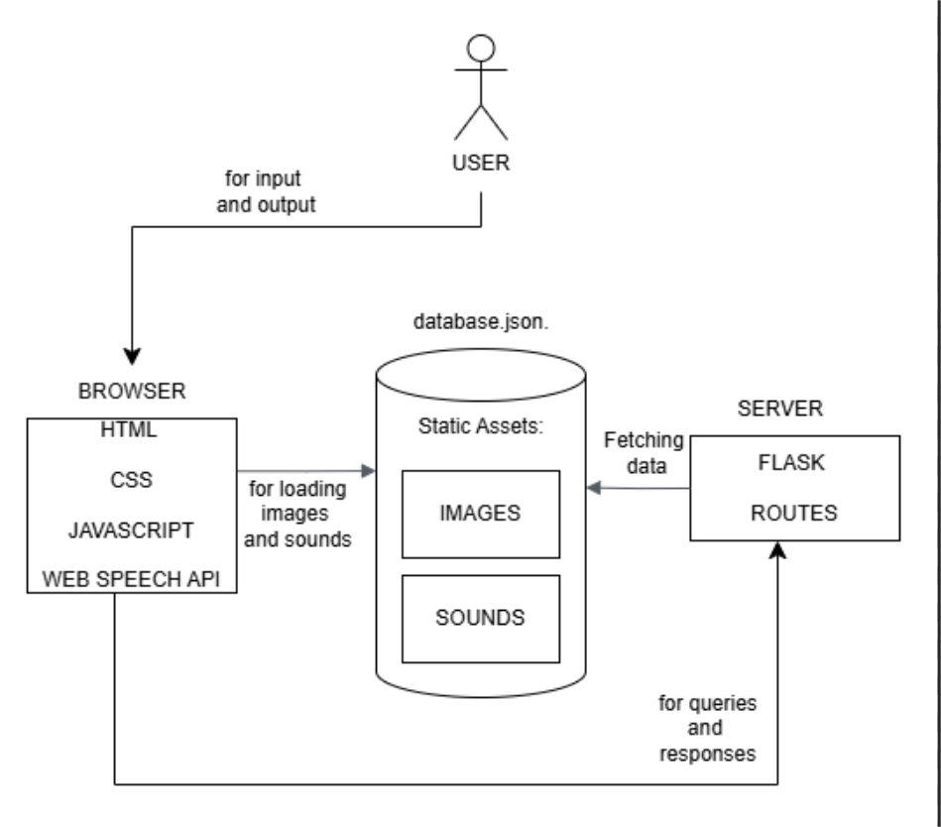

**1. User Interaction :**

Virtual Zoo interface is implemented within the context of a browser and the only way a user can directly engage it. It will be the traffic of the inputs (as the navigator or requests) and the outputs (as pictures, sounds, data, etc.).

**2. Frontend (Browser) :**

The interactive user Interface is done using HTML, CSS and JavaScript for the browser. It also employs audio communiqué through the Web Speech API which can either play out sounds or allow voice command.

**3. Static Assets :**

Icons and briefing sounds are used as the static resources of the system, which belong to the database, for instance, `database.json`. Such assets contribute to creating the zoo’s virtual model and provide a video and an audio signal.

**4. Backend (Server) :**

On the backend server, the Flask is used to manage user requests. It also gets any desired data from static assets for example, if one wants to show an animal’s picture or even play a sound.

**5. Data Flow :**

Each time the user makes a request to a page, the browser passes this request to the server. By applying the defined Flaskroute the query is executed and an information answer is returning back to the browser. Such image, sound or other information is then displayed to the user by the browser on its output screen.

**HARDWARE AND SOFTWARE REVIEW**

**Hardware Review :**

**1. User Device :**

**Specifications :**

The user device could be a personal computer, laptop, tablet or even a smart phone if they have a microphone and speakers for full functionality.

Advantages :

1. Every present day devices with internet connectivity can be able to operate the web based application.
2. It also has practical usability due to common peripherals which are a built-in microphone and speaker.

Limitations :

1. It will not operate to its full potential on older devices with older browser systems, for example, the Web Speech API.
2. Lowly integrated audio or visual effect implies that while playing the game on low-end devices may diminish the immersion.

**2. Server Hardware :**

1. **Minimum Configuration :**

Core2, 4GB RAM and 10GB hard disk space.

Advantages :

1. Reasonable for small applications and for a small number of people.
2. Cost effect and easily accessible hardware.

Limitation:

1. Loading may be slower when many users are active or when large file assets are used.

**B. Recommended Configuration :**

Frequency of four cores, 8 GB of RAM, and an SSD block as internal storage.

Advantages :

1. Ideal to scale the application and offering improved speed levels.
2. SSD storage guarantees a fast and simultaneous retrieval of static data (images, sounds).

Limitations :

1. It takes a little longer to purchase; thus, it has a higher cost as compared to minimum setup.

**3. Network Requirements :**

**Specifications :**

High availability and stability of the connection for client-server data exchanges.

Advantages :

1. Synchronization facilitates efficient transfer of images, sounds and any other forms of assets.

Limitations :

1. Any disruptions to a network that it employs might affect the user experience.

**Software Review :**

**1. Frontend Technologies :**

**Components : HTML, CSS, JavaScript :**

Advantages :

1. These are basic web technologies which they asserted are compatible with most of the current generation browsers.
2. Simple to learn and rapidly effective, especially for the first-tier programmers.
3. Enables the creation of interfaces that would effectively respond to user input and look good in the process.

Limitations :

1. It has comparatively poor functionality enhancement for high demand programs like huge animations or great images.

**Web Speech API :**

Advantages :

1. Adopts more of capabilities like voice enabled commands and response which enlarge the interaction recorded.
2. Supported in all modern versions of browsers including Chrome, Edge.

Limitations :

1. This may have some hitches in all aspects of browsers like the Safari aspect.
2. It is highly dependent on the quality of the receptoricularly the microphone and the extent of noise in the environment.

**2. Backend Framework :**

**Framework : Flask (Python).**

Advantages :

1. Portability in that it is light weighted and can easily be installed for small to medium applications.
2. Usability and can be easily adapted to provide extra functionality using Python libraries.
3. Few changes in terms of request handling functionality and for passing data around.

Limitations :

1. Not as scalable than other large framework (s) such as Django for larger websites with high traffic.
2. It also means that it would need extra effort to implement additional security or other features that a PaaS program may offer.

**3. Data Storage :**

**Format : JSON file (`database.json`).**

Advantages :

1. A format that is easy to read by a human and can handle small datasets.

maintenance is straightforward when it is done in the development stage of the software.

Limitations :

1. Not recommended for use in large datasets or datasets that have to be updated frequently.
2. May not provide results in several cases of big data size but sustain its effectiveness if the data size or the complexities increases. Designing an easy query language which can integrate with a proper Database system may be required (SQLite or MongoDB).

**4. Browser :**

Requirements : Chrome, Mozilla Firefox or Microsoft Edge of the current generation.

Advantages :

1. Position with a good coverage of the latest web standards is practical, thus ensuring an appropriate functionality.
2. Together with a variety of users has the opportunity to accessibility in Microsoft Office.

Limitations :

1. Web Speech API may not be supported in the older browser or any other browser which have not implemented the newer version of HTML5.

**5. Development Tools :**

Requirements : Code editor (e.g., VS Code, PyCharm), Python runtime environment.

Advantages :

1. Widely available tools simplify development.
2. Flask’s simple setup makes development efficient.

Limitations:

1. Limited debugging support compared to more comprehensive frameworks.

**OUTPUTS**

**CONCLUSION**

The virtual zoo create a real furry zoo using technology thus comes out as the best idea to make a project. The combined set of frontend technologies which includes HTML, CSS, JavaScript, and the Web Speech API with a lightweight back-end using Flask gives the project an enhancedcapability that allows users to engage with a number of virtual animals through pictures, audio and textual descriptions. Because of simplicity of the architecture, the development and the subsequent changes are rather easy, and because of that solution is good for applications of small significance only.

This makes the system simple as it only has to refer to the JSON file with the static assets such as images and sounds which are but at the same time makes it difficult to scale the system. To handle large sets of data or any case, where the dynamics of the interaction are extremely high, a shift from this current table system would greatly improve performance in a database system. Similarly while using Flask is most suited for application with low traffic, expanding the system to accommodate high traffic maybe inapplicable without a more complex framework.

The dependencies on components of standard hardware are low which enable the virtual zoo to be hosted with an internet browser on modern social machines. This makes it easy for them to use it as an education and entertainment instrument for all classes of people. Web Speech API for voice interactions also enhances use interaction enhancing and can be used to drive content updating as well; its reliability depends on the browser and quality of the hardware used.

Altogether, the virtual zoo project appears to be one of the most promising, efficient, and easy-to-navigate orientations for using digital technologies in education. The architecture in place is still scalable for use in certainly small scale scenarios for future versions, larger scale application could consider aspects such as interaction with humans and compatibility across different platforms. These improvements would help the people providing virtual zoo experience to reach out to a larger audience and provide an even more realistic and interesting trip which would also be informative.